NEWCASTLEGATESHEAD INITIATIVE PERFORMANCE DASHBOARD JANUARY 2012
DESTINATION PERFORMANCE
- Weekday(Mon – Thurs)  Hotel Room Occupancy | - Weekend (Fri – Sat)  Room Occupancy | - Average Weekly RevPar Comparisons | - Hotel Forward Bookings City Centre | - Conference Tourism
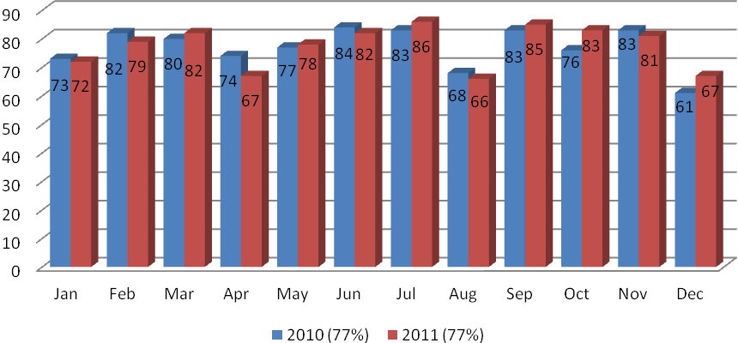 | 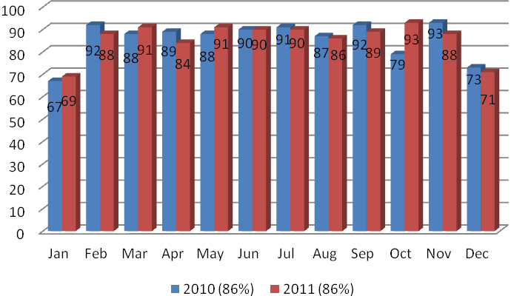 | 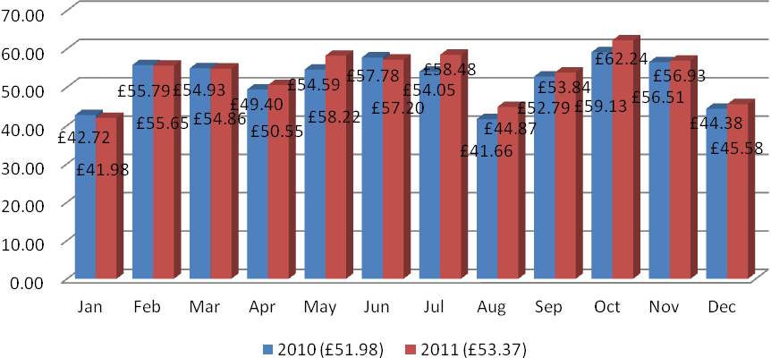 | 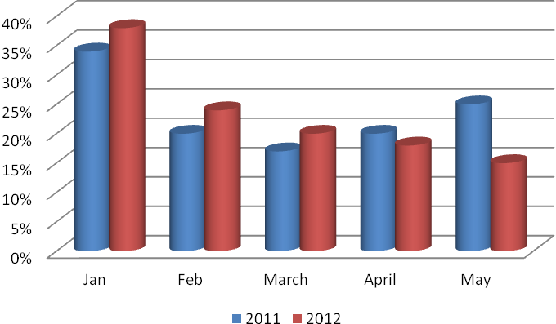 | - 1.5 million people travelled to NewcastleGateshead for conferences and meetings in 2010  - These visitors spent 2.45 million days in the destination  - Expenditure by these visitors had grown by 16% compared to 2009 up to £277 million  - 6,332 jobs are directly supported by the conference and meeting sector, up by 11%
- Paid attraction % change year on year | - Free attraction % change year on year | - Total Quaylink Passenger numbers | - Air passenger numbers by origin with % change November | - Eldon Square Footfall (Year on Year trend)
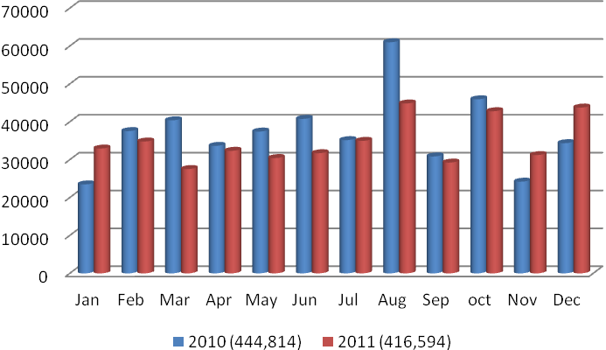 | 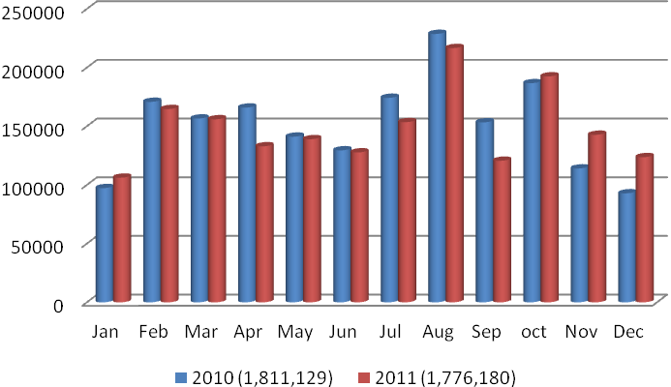 | 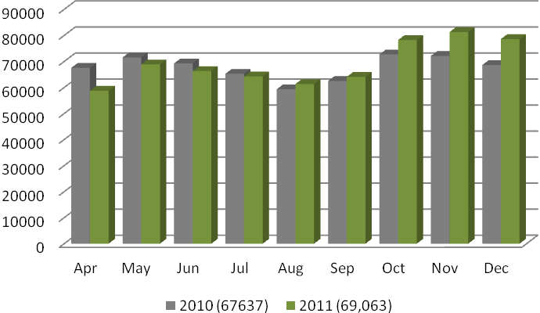 | 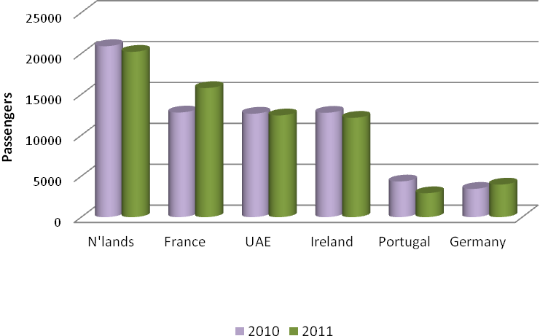 | 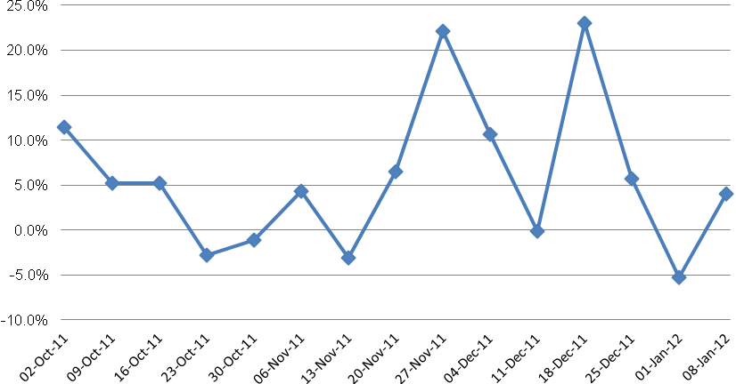
IN SUMMARY:
1,2, 2011 has seen both weekend and weekday occupancy remain consistent with 2010 despite the increase in bedstock. In the case of December midweek occupancy is up by 6 percentage points while weekend occupancy fell slightly. This fall in weekend occupancy appears to be skewed by the weekend of Christmas and the fact Christmas fell on a Saturday therefore bringing occupancy down significantly.

3. The highlight for hotel operators is the year on year growth in RevPar with the average weekly RevPar for 2011 ending at £53.37 up from £51.98. Part of this can be put down to the strength of the conference and meetings sector reflected in point 5 and the fact hoteliers have had less pressure to discount rates during 2011.

4. The first 3 months of 2012 have higher levels of forward bookings than at the same time in 2011, however May is significantly down. This may, in some part, be due to the moving of the second bank holiday from May to June to coincide with the Queen’s Jubilee.

6. Despite a strong end to 2011 both free and paid attractions saw a drop in visitor numbers when compared to 2010 as the economic climate saw consumers taking less day trips

- A strong December for the Quaylink contributed to total passenger numbers in excess of 620,000 in 2011, an average of more than 69,000 a month. This was up by 3% on the levels of 2010 with factors such as the opening of the Jurys Inn NewcastleGateshead Quays, the Turner Prize at BALTIC and construction workers travelling to work on projects on the Quayside all contributing.

Key upcoming dates:

Chinese New Year – 29th January

Theatre Royal Birthday Blaze 16th – 19th Feb

Gateshead International Jazz Festival 23rd – 25th March

Datasources:
Regional Occupancy Surveys, Lynn Jones Research and The Research Solution
Attractions Survey, ONE
Tourism Investment Monitor, ONE
UK Tourism Survey, VisitBritain

